Nhat Doan_ CSC134_Midterm_Question 3

3. Draw an ER diagram according to the following requirements. (30 points)

The bank application keeps track of the following information. As a customer of the bank, he/she must either own an account or borrow a loan. The banking application does not require a customer to both own account and borrow a loan. Customer information includes a SSN (unique), a name, and an address. A customer can borrow at most one loan. A loan has a loan number (unique) and an amount. A loan must be borrowed by at least one customer. An account has an account No (unique) and an amount. A customer may own many accounts. An account can be owned by many customers, at least one. The date that a customer starts to own an account also needs to be recorded.

Answer:

[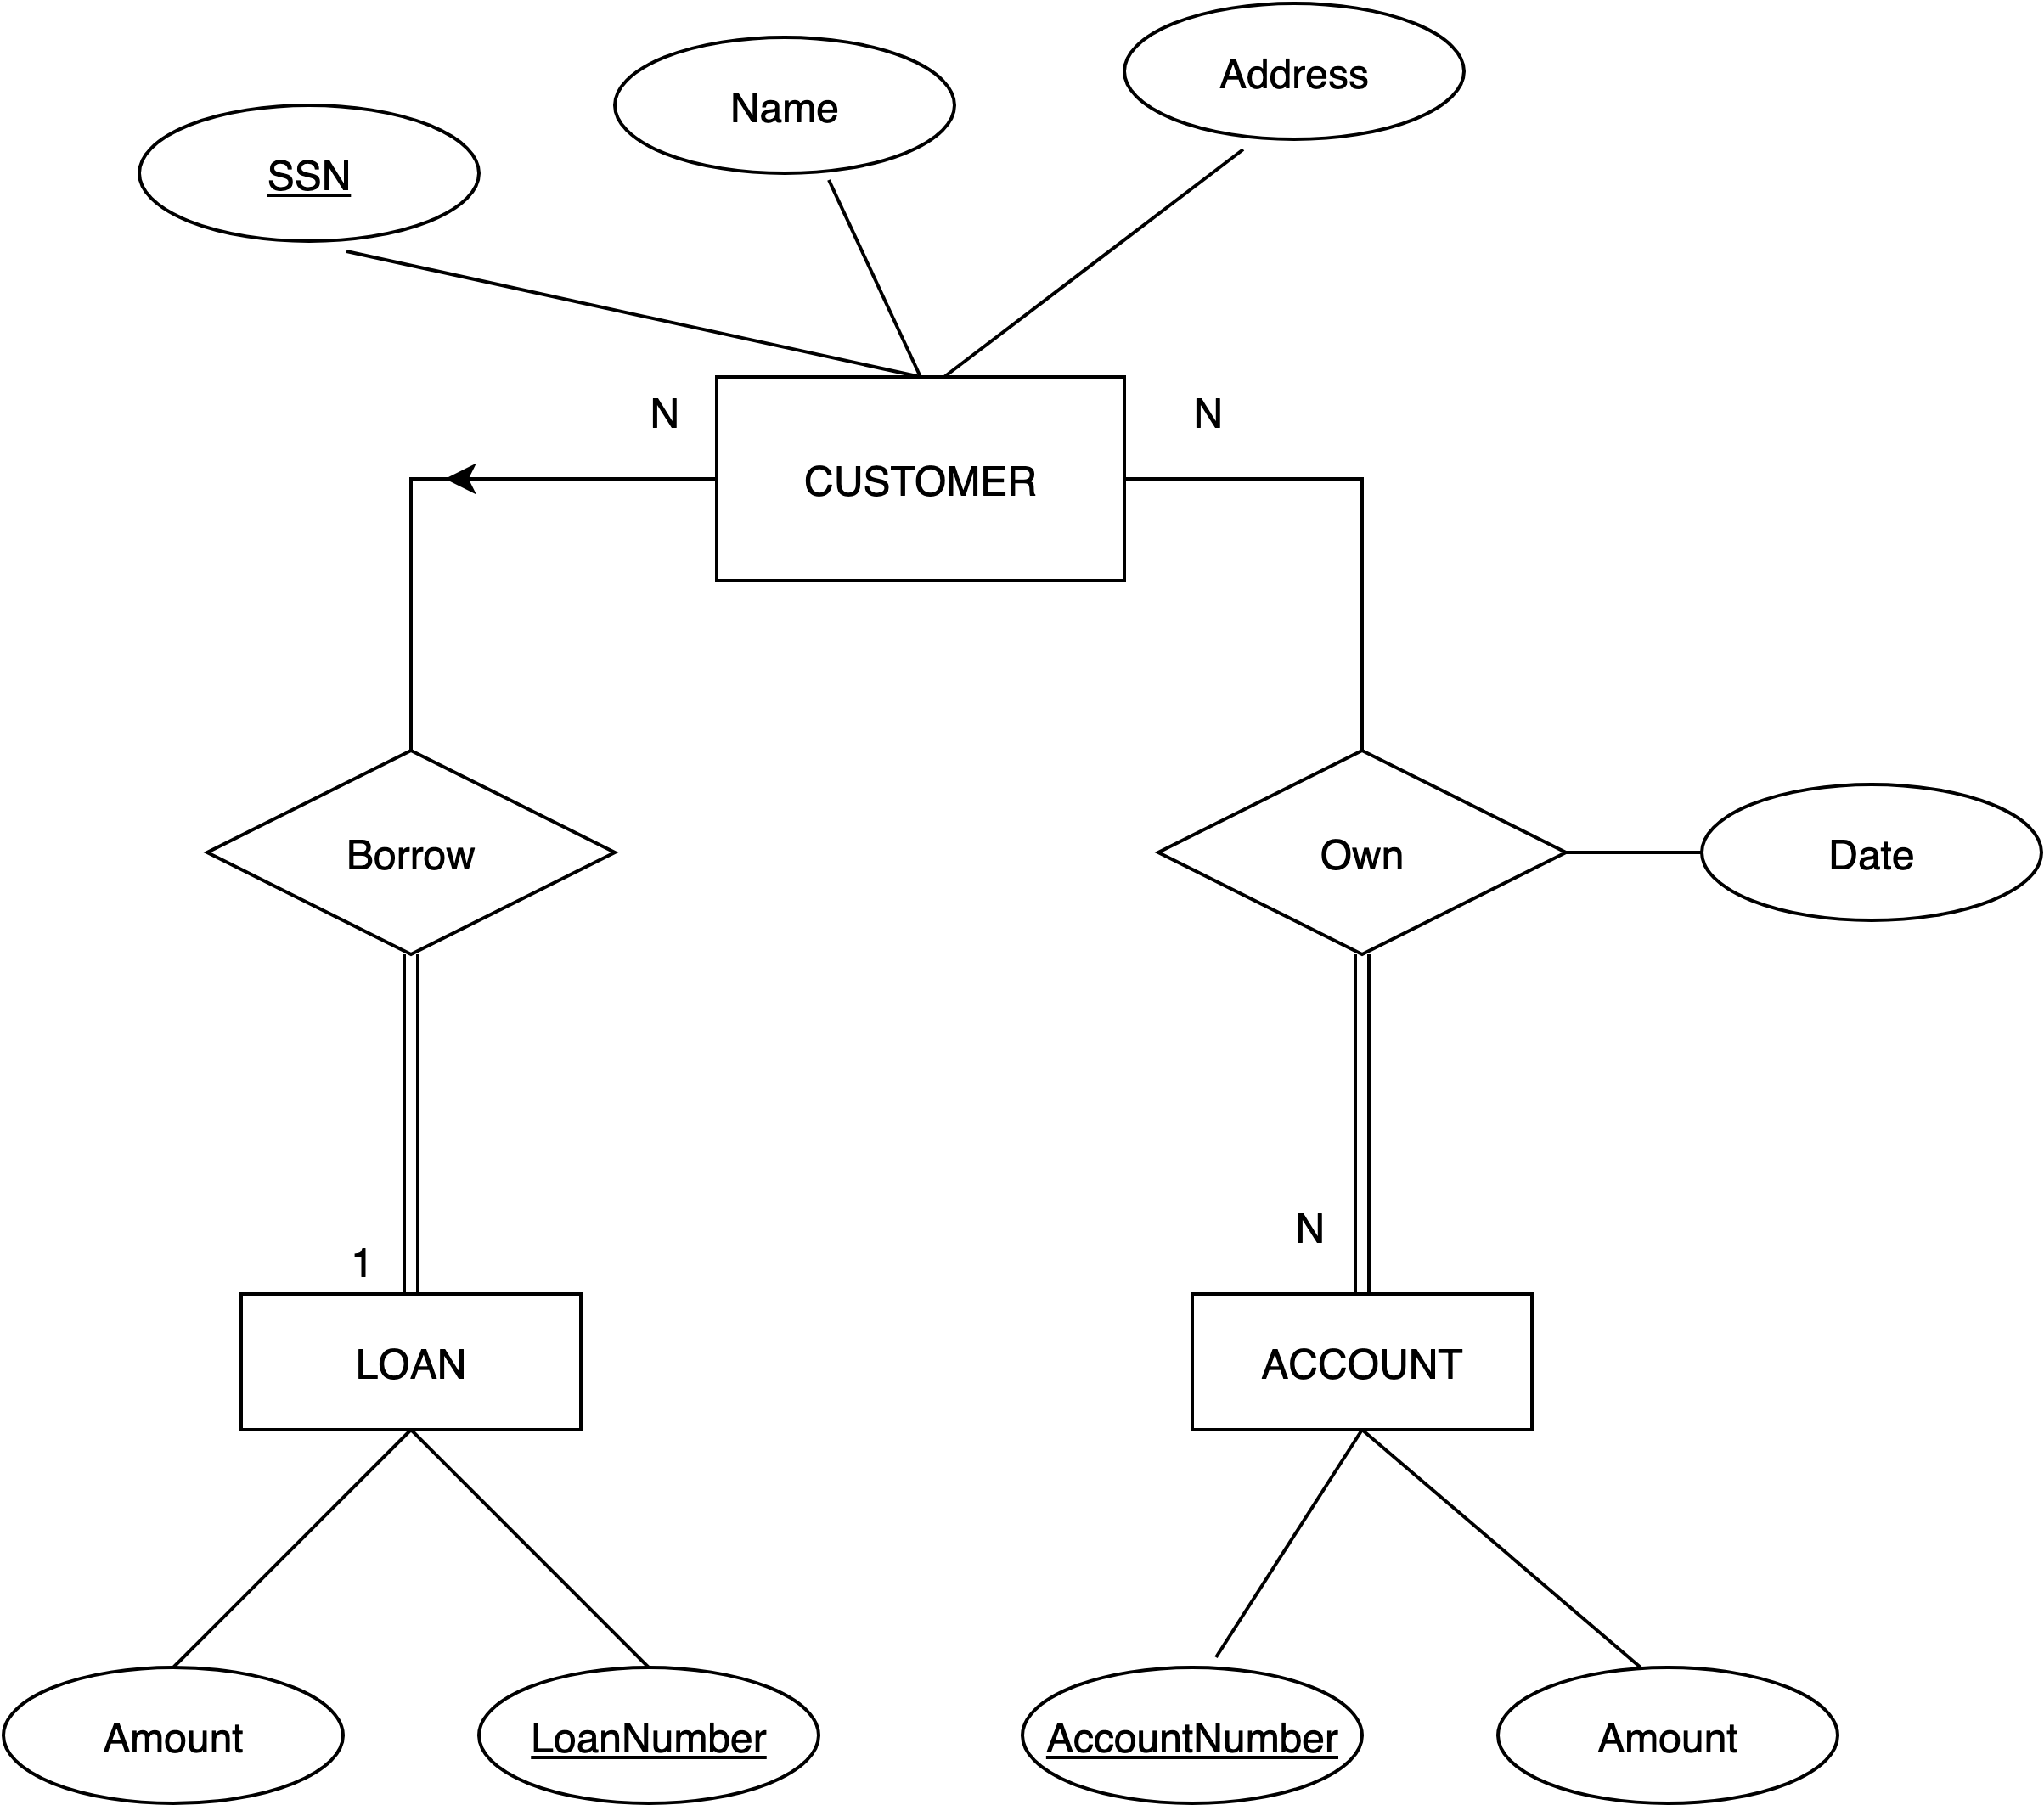](https://www.draw.io/?page-id=C5RBs43oDa-KdzZeNtuy&scale=auto#G1YQri3zi0qj1ySiQRBc8EEgwgcXfc6u_d)